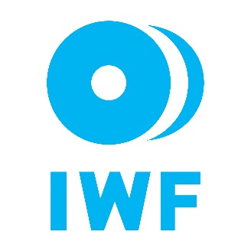
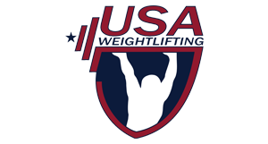
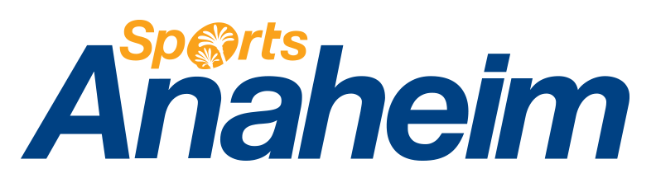

October 26, 2016

INVITATION TO THE 2017 IWF WORLD WEIGHTLIFTING CHAMPIONSHIPS AND 2017 PAN AMERICAN CHAMPIONSHIP (PAN AMERICAN GAMES QUALFICATION & CENTRAL AND CARIBBEAN ISLAND GAMES QUALIFICATION EVENT)

Dear Presidents and General Secretaries,

On behalf of the Anaheim Local Organizing Committee for the 2017 IWF World Weightlifting Championships and IWF Congress Meetings, we would like to extend a formal invitation to all 188 affiliated National Federations worldwide and covering five continents, to participate in this event. The competition and meetings will be held at the Anaheim Convention Center, Anaheim, California, USA on November 1, 2017 to December 10, 2017 to include the training camp period. It is a great honor for the United States, after also hosting the 2015 IWF World Championships, to host the World Weightlifting Championships once again. In conjunction to the competition, USA Weightlifting will be offering a specialized training and coaching camp to take place two weeks prior to the Championships, inclusive in the above dates.

The United States will also host the 2017 Pan American Championship (a qualification event for the 2019 Pan American Games and 2018 Central America & Caribbean Island Games) in Miami, Florida, USA and the Congress of the Pan American Weightlifting Federation from July 20-31, 2017 at the Miccosukee Resort, Miami, Florida, USA. It is strongly advised to apply for the visa for both competitions at the same time.

The tournament is truly the most important sporting competition in the world of weightlifting, and it is important we have as many countries as possible participate. The Anaheim Local Organizing Committee, which includes USA Weightlifting, is privileged to welcome you to our wonderful country and city for this very prestigious occasion.

Please begin the process of securing your travel visas for entry into the United States by applying online at http://www.travel.state.gov. It is essential to do this as soon as possible. We highly recommend to begin application by June 15, 2017. Please note that all team/delegation members will need to file individual applications. Part of the application process also requires that each person schedule an appointment to appear in person for an interview at the Embassy or Consulate where they have filed their application. In order to ensure that your delegation’s application process is as efficient as possible, please ensure that each member carries a copy of this letter with them to the interview date and that they also present it to the U.S. Customs official when they enter the United States.

If you have any questions, please contact me directly. We look forward to your participation in this event and wish you safe travels.

Sincerely,

Phil Andrews
Chief Executive Officer & General Secretary
USA Weightlifting
1 Olympic Plaza, Colorado Springs, CO, 80909 USA
Telephone: +1 719 200 6020
Email: phil.andrews@usaweightlifting.org
Roy Edmondson
Vice President, Sports Development
Sports Anaheim/Visit Anaheim
800 West Katella Avenue, Anaheim, CA, 92802 USA
Telephone: +1 714-765-8845
Email: redmondson@visitanaheim.org

cc: David Francis, Manager, Government Relations, USOC; David.Francis@usoc.org

