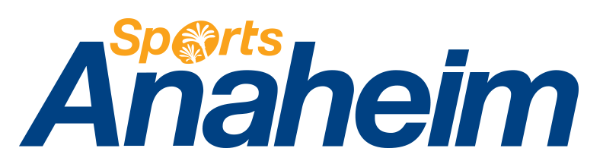
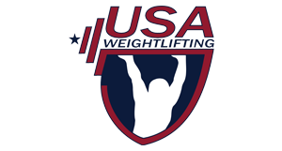

April 20, 2017

Dear Presidents and General Secretaries,

The 2017 IWF World Championships Organizing Committee formally invites the athletes of the 188 affiliated National Federations worldwide and covering five continents, to participate in the 2017 World Weightlifting Championships Preparation Camp in Las Vegas, Nevada, USA prior to the 2017 WWC in Anaheim, California, USA.

Delegations from seven countries will have access to lodging, food and training from November 12th to November 24th. The 2017 IWF World Championships will be held at the Anaheim Convention Center from November 28th to December 5th, 2017.
Delegations will be housed at the Excalibur Las Vegas Hotel & Casino while training will be held at Average Broz Gym. The travel time between the Hotel and the training site is 15 minutes.

Pricing for the camp is $115 (USD) per day for double occupancy and $165 (USD) per day for single occupancy for each member of a nation’s delegation. The fee includes housing, 3 meals per day at the hotel restaurant, training (2 or 3 times daily) and transportation to and from the hotel and training site, as well as a group bus transfer from Las Vegas to the 2017 WWC in Anaheim, California, USA.
.
The minimum stay is 12 nights. Upon request, add-ons can be provided to complete the athlete’s training experience before the World Championships. Add-ons include massage therapy and chiropractic services, with rates to be further discussed. For more information and interest forms, CLICK HERE.

Due to space constraints only seven delegations will be able to attend the camp. Pre-Payment of all fees and add-ons are required. All payments are due October 4, 2017. Delegations interested in attending should contact Suzy Sanchez (suzy.sanchez@USAWeightlifting.org) by September 4, 2017. A slot at training camp is not secured until a Federation pays its event fees in full.

Visa Information:
Very Important… Please begin the process of securing your travel visas for entry into the United States by applying online at http://www.travel.state.gov. Please note that all team/delegation members will need to file individual applications. Part of the application process also requires that each person schedule an appointment to appear in person for an interview at the Embassy or Consulate where they have filed their application. In order to ensure that your delegation’s application process is as efficient as possible, please ensure that each member carries a copy of this letter with them to the interview date and that they also present it to the U.S. Customs official when they enter the United States.

If you have any questions please contact us directly. We look forward to your participation in this event and wish you safe travels.

Sincerely,

Phil Andrews
Chief Executive Officer & General Secretary
USA Weightlifting
1 Olympic Plaza, Colorado Springs, CO, 80909 USA
Telephone: +1 719 200 6020
Email: phil.andrews@usaweightlifting.org
Roy Edmondson
Vice President, Sports Development
Sports Anaheim/Visit Anaheim
800 West Katella Avenue, Anaheim, CA, 92802 USA
Telephone: +1 714-765-8845
Email: redmondson@visitanaheim.org

cc: David Francis, Manager, Government Relations, USOC; David.Francis@usoc.org

